Question 1):

1A)

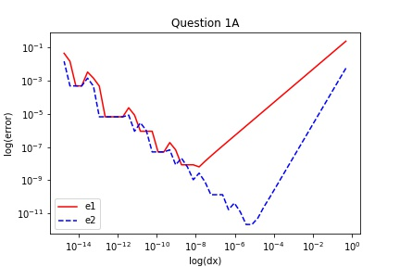

1B)

p1: 0.023494283459872763 p2: 1.6532335417270845e-06 p3: -0.1411200337763976

True derivative at dx = 0: -0.1411200080598672

Extrapolated derivative from polynomial fitting: -0.1411200337763976 with an error of: 2.5716530377417612e-08

The error of the dx = .025: 1.4699541470569732e-05

The error of using dx = 0 instead of dx = .025 with within 3 orders of magnitude better.

1C)

p1: -0.00022042382249622494 p2: 0.023532857628819914 p3: -2.7547490426023543e-07 p4: -0.14112000622341977

True derivative at dx = 0: -0.1411200080598672

Extrapolated derivative from polynomial fitting: -0.14112000622341977 with an error of: 1.8364474385634821e-09

The error of using dx = 0 instead of dx = .025 with within 4 orders of magnitude better.

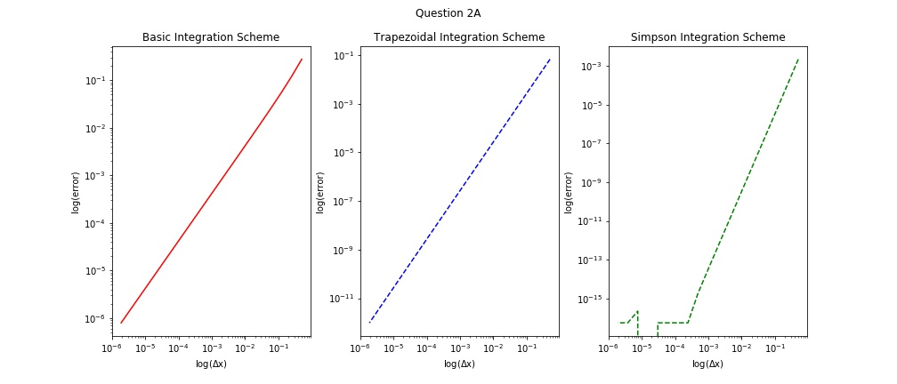Question 2):

2A):

2B)

p1: -0.00800091966070037 p2: -0.26721638680999354 p3: -0.000251867463712889 p4: 0.4024564217758112

True integral: 0.40244801710422107

Extrapolated integral from polynomial fitting: 0.4024564217758112 with an error of: 8.40467159013425e-06

The error with dx = 1/16: 0.004213961601492566

The error of using the extrapolated dx = 0 instead of dx = 1/16 is within 3 orders of magnitude better

Question 3)

3A)

root 1: 0.314143624943681

root 2: 1.7029530502855779

integral = 6.286959421352375

3B)

root 1: 0.2928932189336046

root 2: 1.7071067817509176

computed integral = 6.283185348420567

Actual integral: 6.283185307179586